**CodeX Energy Drink Project-SQL Queries**

1. 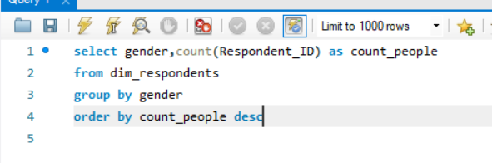**Who prefer Energy drink More?**

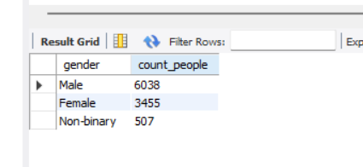

1. 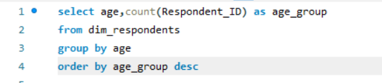**Which age group prefer energy drink more?**

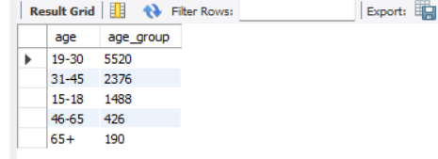

**3.What are the preferred ingredients of energy drinks among respondents?**

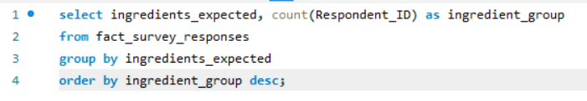

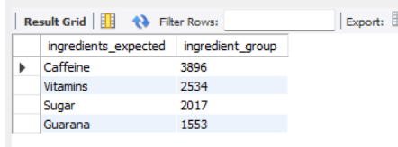

**4.What packaging preferences do respondents have for energy drinks?**

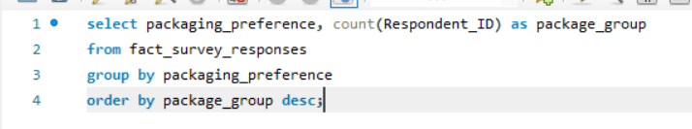

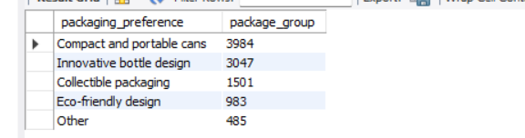

**5.** **Who are the current market leaders?**

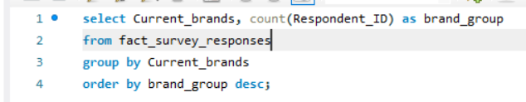

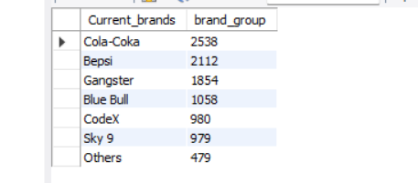

**6.What are the primary reasons consumers prefer those brands over ours?**

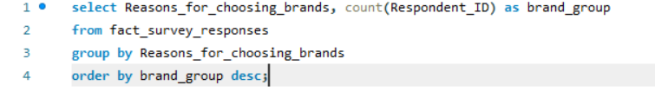

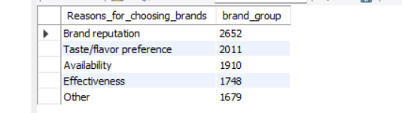

**7.Which marketing channel can be used to reach more customers?**

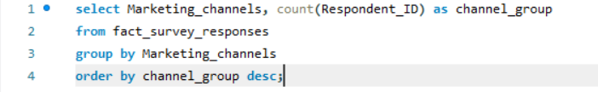

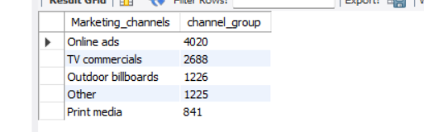

**8.How effective are different marketing strategies and channels in reaching our customers?**

**9. What do people think about our brand? (overall rating)**

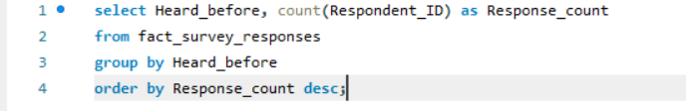

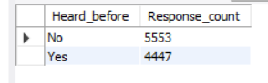

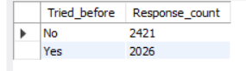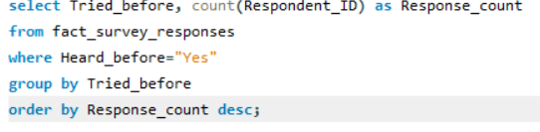

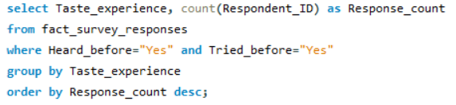

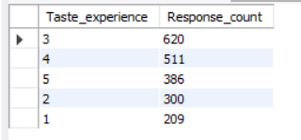

**10.Which cities do we need to focus more on?**

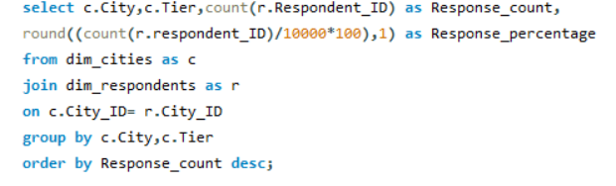

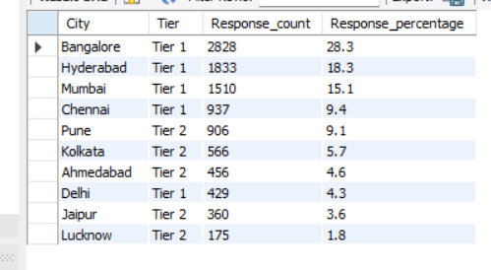

**11.Where do respondents prefer to purchase energy drinks?**

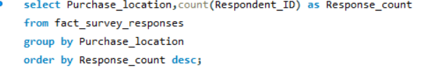

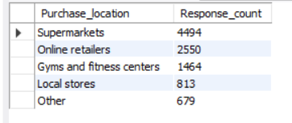

**12.What are the typical consumption situations for energy drinks among respondents?**

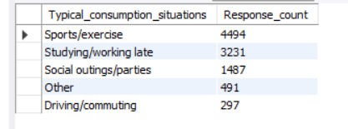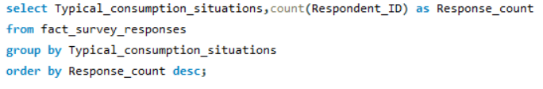

**13. What factors influence respondents' purchase decisions, such as price range and limited edition packaging?**

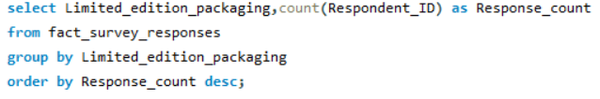

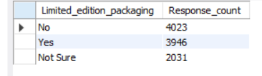

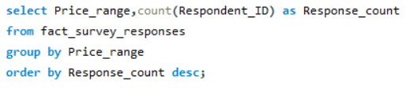

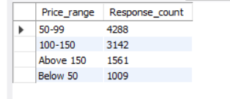

**14.** **Which area of business should we focus more on our product development? (Branding/taste/availability)**

